**Course Evaluation System Use Cases – G5**

Muhammad Bilal (Team Lead)

Salman Ahmad

Ali Ahmad Mumtaz

**UC1: Specify Major Instrument – Salman Ahmad**

**Primary Actors**

**Course Administrator**

Responsible for defining major instruments for each course.

**Instructors**

Provide input on major instruments and their respective minor instruments for each course.

**Stakeholders and Interests**

**Department of Computer Science**

Interested in defining major instruments for accurate evaluation.

**Instructors**

Interested in specifying appropriate major and minor instruments for their courses.

**Preconditions**

1. The Course Management System is operational.
2. Courses for the semester are identified and available in the system.

**Success Guarantee (Postconditions)**

1. Major instruments are defined for each course.
2. Instructors can access and confirm the defined major instruments for their courses.

**Basic Flow**

**Access Major Instruments Section**

The Course Administrator logs into the system and accesses the major instruments management section.

**Select Course**

Course Administrator selects a specific course for which major instruments need to be defined.

**Define Major Instrument**

The Course Administrator defines the major instrument for the selected course (e.g., ‘sessional’).

**Set Percentage Division**

The Course Administrator specifies the percentage division of marks within the major and instruments (e.g., 50% for the major instrument).

**Confirm and Save**

The Course Administrator confirms the defined major instruments for the course and saves the information.

**Instructor Confirmation**

1. Instructors associated with the course receive notifications about the defined major instruments.
2. Instructors log in, review the defined instruments, and confirm their accuracy.

**System Update**

The system updates the course information with the defined major instruments and their corresponding minor instruments.

**Alternate Flows**

**Incorrect Definition**

If the Course Administrator incorrectly defines major, the system allows for corrections before confirmation.

**Instructor Discrepancy**

If instructors disagree with the defined major instruments, they can request modifications. The Course Administrator reviews and makes necessary changes.

**Special Requirements**

**Real-time Updates**

The system must ensure real-time updates to reflect changes made in major instruments.

**User Notifications**

Instructors must receive notifications about the defined major instruments to confirm their accuracy.

**Technology and Data Variation List**

**Technologies**

Web-based application, Database, Server-Side Scripting.

**Data Variations**

Course details, major instrument names, percentage division of marks, user confirmations.

**UC2: Specify Minor Instrument – Ali Mumtaz**

**Primary Actor**

Instructor

**Stakeholders and Interests**

**Instructor**

They are interested in specifying minor instruments to accurately assess and evaluate students’ performance in the course.

**Students**

They benefit from a well-structured evaluation system, as it ensures fair and transparent assessment.

**University Administration**

Interested in obtaining accurate course evaluation data to improve academic programs.

**Preconditions**

1. The user must have valid authentication and authorization to access the system.
2. A course must already be created and accessible within the system.

**Success Guarantee (Postconditions)**

The specified minor instruments and their criteria are associated with the course in the course evaluation system.

**Main Success Scenario (or Basic Flow)**

1. The instructor navigates to the course for which they wish to specify minor instruments.
2. The system displays a list of major instruments associated with the course (e.g., 'sessional').
3. The instructor selects a major instrument (e.g., 'sessional') to specify minor instruments within it.
4. The system provides an interface for defining the minor instruments and their respective criteria, such as their names and the percentage division of marks.
5. The instructor enters the name of the minor instrument (e.g., 'sessional 1') and specifies the percentage division of marks for this minor instrument.
6. If multiple minor instruments exist within the major instrument, the user may choose to repeat steps 5 and 6 to add more minor instruments.
7. The instructor saves the defined minor instruments and criteria for the selected major instrument.
8. The system stores the information regarding the specified minor instruments and their criteria for the course.
9. The instructor may choose to repeat steps 5-9 for any additional major instruments within the course.

**Extensions (or Alternative Flows)**

1. If the user cancels the process at any point before saving, the system discards the changes made, and no minor instruments are specified for the course.
2. If there are errors or inconsistencies in the input data (e.g., percentage division does not add up to 100%), the system provides appropriate error messages and prompts the user to correct them.
3. In case the user wishes to modify or delete specified minor instruments in the future, they can revisit this use case and make the necessary changes.
4. If the user lacks the necessary permissions, the system will deny access to this use case.
5. If the course evaluation system is to be extended to all departments in the university, the use case might need to be adapted to accommodate cross-departmental considerations and access control.

**Special Requirements**

1. The system should allow for the dynamic addition and modification of minor instruments to ensure flexibility in the course evaluation process.
2. The system should provide validation checks to ensure the sum of percentage divisions equals 100% for each major instrument.

**Technology and Data Variations List**

1. The system should support various web browsers and devices for user accessibility.
2. Data related to minor instrument specifications should be stored securely and be accessible only to authorized users.

**Frequency of Occurrence**

This use case is expected to occur at the beginning of each academic semester when courses are set up and configured.

**Open Issues**

1. Determining the level of access control and permissions for different users within the system.
2. Consideration of cross-departmental requirements if the system is extended to all university departments.

**UC3: View Result - Muhammad Bilal**

**Primary Actors**

Instructor, Admin and Student.

**Stakeholders and Interests**

**Instructor**

Instructors are interested in viewing the academic results of their students to assess their performance in the courses they are responsible for.

**Admin**

Admins are concerned with the overall management of the academic data. They may need to access student results for various administrative purposes, such as accreditation, reporting, and monitoring institutional performance.

**Student**

Students are keen to view their own academic results to gauge their performance, track their progress, and identify areas of improvement.

**Institutional Authorities**

Institutional authorities, such as deans or academic directors, may use the "View Results" feature to assess the overall performance of courses and make informed decisions about curriculum changes and resource allocation.

**Preconditions**

1. The user must have valid authentication and authorization to access the system.
2. Student data and course evaluation results must be available in the system.

**Success Guarantee (postconditions)**

1. The user can access and review the academic results for the selected course or student.
2. Instructors and Admins can access results for multiple courses and students, including aggregate data.
3. Students can view their own academic results.
4. The results can be printed or saved for future reference.

**Basic Flow**

1. If the user is an instructor or Admin, they can access the "View Results" feature. If the user is a student, they can access their own academic results.
2. The user selects a course for which they want to view results.
3. The system retrieves and displays the relevant academic results for the selected course.
4. If the user is an instructor or Admin, they can view results for multiple students and courses.
5. The user can view detailed information, including individual student marks, grades, and positions within the course.
6. Instructors and Admin can also access aggregate data such as class averages and statistics.
7. The user has the option to print or save the results for reference or record-keeping purposes.

**Alternate Flows**

1. If the user's credentials are invalid or they lack the necessary permissions, they will be denied access to the "View Results" feature.
2. If there are no results available for the selected course or student, the system will display a message indicating the absence of data.
3. If there are technical issues or system errors, the system will prompt the user to try again or report the problem to the administrator.

**Special Requirements**

1. Data should be updated in real-time or at regular intervals.
2. The system should be able to handle a potentially large volume of users accessing results concurrently, especially during peak times such as exam result releases.
3. The system should ensure seamless integration with the course allocation system, course management system, and other relevant systems to provide a holistic view of student performance.

**Technology and Data Variations List**

1. The result should be accessible via standard web browsers and potentially a mobile application.
2. The user interface should be responsive to different screen sizes and devices.
3. Results data can vary in terms of formats, such as letter grades (A, B, C) or numerical scores (0-100).

**Frequency of Occurrence**

Instructors may use it regularly to monitor student progress, while students and admin may access it periodically for various administrative and academic purposes.

**Open Issues**

**Data Privacy and Security**

Ensuring that student data is securely managed and only accessible to authorized individuals while complying with data privacy regulations.

**Usability and Accessibility**

Addressing user interface design and accessibility concerns to make the feature user-friendly and accessible to all stakeholders, including individuals with disabilities.

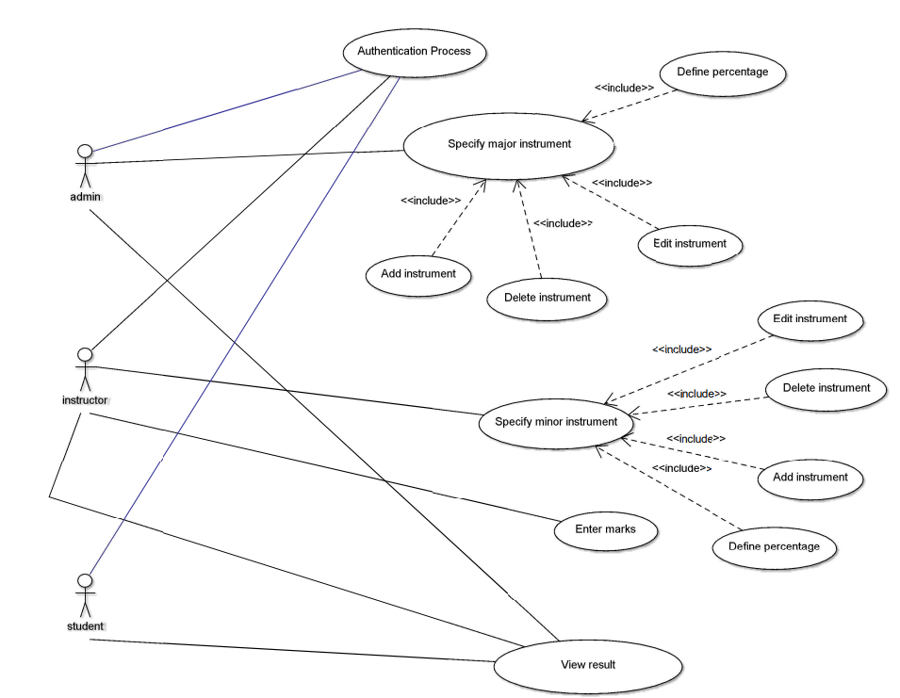**Use Case Diagram – Course Evaluation System**